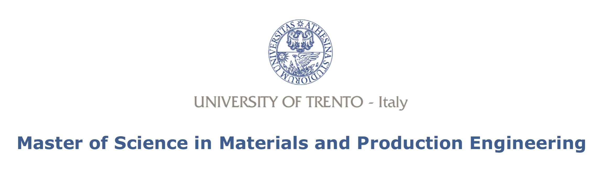

**Melt flow index (MFI), Shore hardness, Vicat/HDT and LOI analysis**

Laboratory activity report

Course of Polymeric Materials Engineering

Giacomo Mori 207674

Veronica Pallua 206956

Lorenzo Penna 208221

Gabriel Orsi 207696

Rosa Ilaria Quercia 207014

Laura Simonini 207317

Alessandro Sorze 207017

Federico Vespa 206913

Trento (Italy), jun 2019

Academic year 2018-19